JavaFx Hello World Lab Report

1) Enter your name, student ID, platform (Mac or PC) and date
Name and Student ID: Jibran akhter - 1073973
Platform (Mac, PC, Linux, etc.): Windows PC
Development System (NetBeans, Eclipse, etc.) Eclipse
Date: 5/6/2024

PROJECT DESCRIPTION:
Section 6.1.1 in the textbook has a sample program for a JavaFX application. Take the code that is provided for this example and modify it to
1) include your name in the label.
2) Add one additional button that changes the message label text to read "Success".
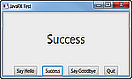
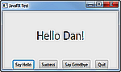
The code to implement the new button should be message.setText("Success");

Add a new Button
Change the message to show your name

IMPORTANT INFORMATION IF YOU USE ECLIPSE:
JavaFX support is automatically included in NetBeans, but Eclipse by default does not provide support for JavaFX. There are two ways to get Eclipse to work with a JavaFX project:
1) Include a JAR file with each and every JavaFX project that you want to build.
2) Add the JavaFX plug-in to Eclipse which enables you to create a JavaFX project from within Eclipse
Here is a link to an excellent YouTube video that explains how to do each method. The description of how to add the JavaFX plug-in to Eclipse starts at 5:25 in the video
https://www.youtube.com/watch?v=ejx3VxuIc8w
DISCUSSION:
1) Complete the DISCUSSION section in English. It does not need to be long, but it needs to be complete.
1a) What did you do to develop the program?
I had to configure JavaFX by adding its library to the project’s build path, which is essential for using JavaFX components since they are not included in JDK 11 and later versions. I reviewed the requirements for the application, which included creating a GUI with labels and buttons that interactively updates the text displayed based on user input. This involved a `BorderPane` layout where the central area displays a label, and the bottom area contains buttons.

1b) What problems did you have and how did you overcome the problems?
Initially, the application wouldn’t launch because of improper setup of the JavaFX SDK in Eclipse. The JavaFX library wasn't recognized, so I adjusted the project's build path to include the JavaFX SDK libraries. Additionally, I set the VM arguments in the Eclipse run configurations to specify the module path and to add necessary JavaFX modules. After configuration, I faced an issue where the application did not execute, displaying the error "The selection cannot be launched, and there are no recent launches." I checked the run configurations to ensure that the correct class was set as the main entry point. I also rechecked the VM arguments to confirm they were correctly pointing to the JavaFX library path and that the necessary modules were added.

PROGRAM OUTPUT:
2) Provide screenshots showing correct operation of the program. Refer to previous lab assignments to review how to save a screen shot to the lab report. Adjust the size of the image on the report to show the summary information and the image of the paycheck.

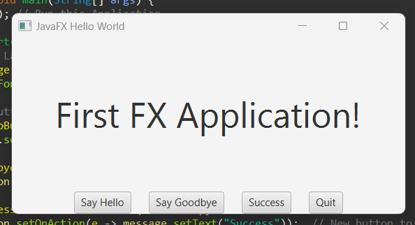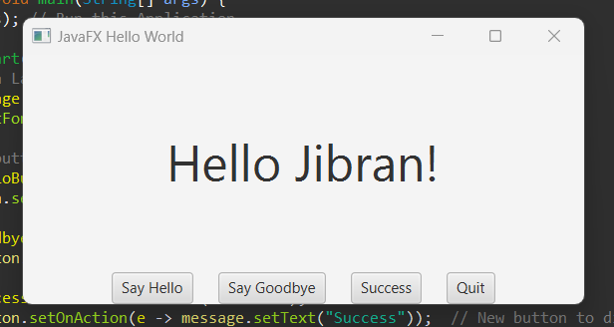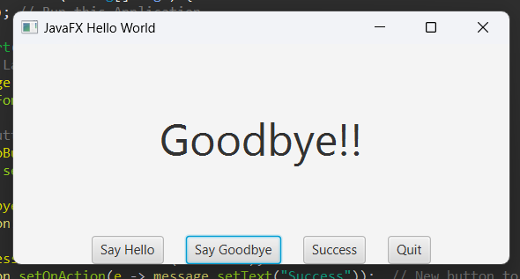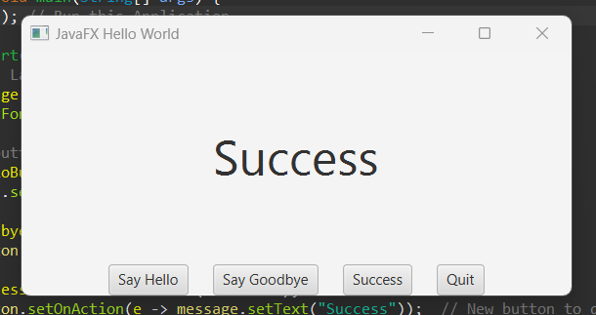

PROGRAM LISTING:
3) Copy and paste the code that YOU typed to make the program work. Your program should include a comment block at the top that shows the name of the program, date and your name.

/*
Name: Jibran Akhter - 1073973
Date: 5/6/2024
GUI Project: Hello World - Using JavaFX Library
*/
package application;

import javafx.application.Application;
import javafx.scene.Scene;
import javafx.stage.Stage;
import javafx.application.Platform;
import javafx.scene.layout.BorderPane;
import javafx.scene.layout.HBox;
import javafx.geometry.Pos;
import javafx.scene.control.Label;
import javafx.scene.control.Button;
import javafx.scene.text.Font;

public class JavaHelloWorldFX extends Application {
public static void main(String[] args) {
launch(args); // Run this Application.
}
public void start(Stage stage) {
// Create a Label with your name and initial message
Label message = new Label("First FX Application!");
message.setFont(new Font(40));

// Create buttons that can be clicked which change the message Label
Button helloButton = new Button("Say Hello");
helloButton.setOnAction(e -> message.setText("Hello Jibran!"));

Button goodbyeButton = new Button("Say Goodbye");
goodbyeButton.setOnAction(e -> message.setText("Goodbye!!"));

Button successButton = new Button("Success");
successButton.setOnAction(e -> message.setText("Success")); // New button to display "Success"

Button quitButton = new Button("Quit");
quitButton.setOnAction(e -> Platform.exit());

// Create an HBox to hold the buttons
HBox buttonBar = new HBox(20, helloButton, goodbyeButton, successButton, quitButton);
buttonBar.setAlignment(Pos.CENTER);

// Create a BorderPane named root to hold the message Label in center and the Buttons on the bottom
BorderPane root = new BorderPane();
root.setCenter(message);
root.setBottom(buttonBar);

// Create the displayable scene to hold root, set the title and show it
Scene scene = new Scene(root, 450, 200);
stage.setScene(scene);
stage.setTitle("JavaFX Hello World");
stage.show();
} // end start();

} // end class HelloWorldFX

